Holding deposit:

The application fee comprises of 1 weeks rent and should be paid once the Landlord has accepted your application (subject to contract). Please do not send payment until we have requested it.

Payments should be made to:

Bank name: Barclays Bank

Account number: 73438880

Sort Code: 20-84-61

Account name: Paxtons Estate Agents (Lettings) Limited

Please note, in the event that you fail references, provide incorrect information, or should you withdraw your application then your holding deposit will be forfeited. In the event that the Landlord withdraws then you will receive a full refund.

Please could each adult planning to reside in the property complete and return this form to us at their earliest opportunity along with two forms of ID (preferably one form of ID should be their passport). Once we have received the form(s) and application fee, the property will be reserved for you.

If you have any questions, please contact us on:

Telephone: 01225 777 696

Email: natalie@paxtonsresidential.co.uk

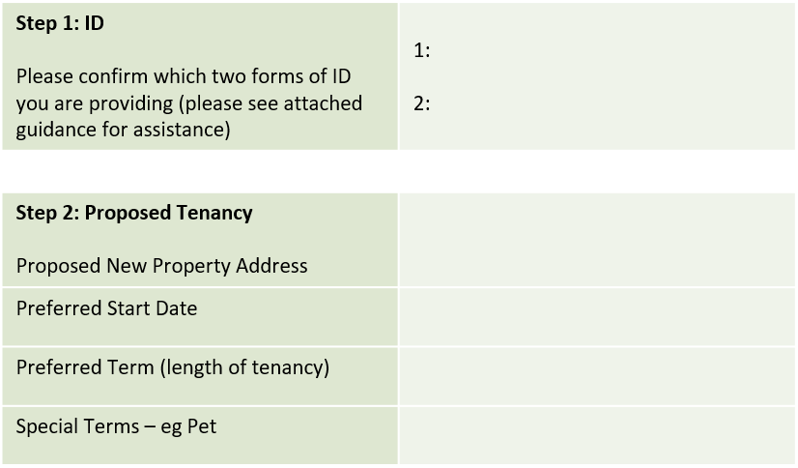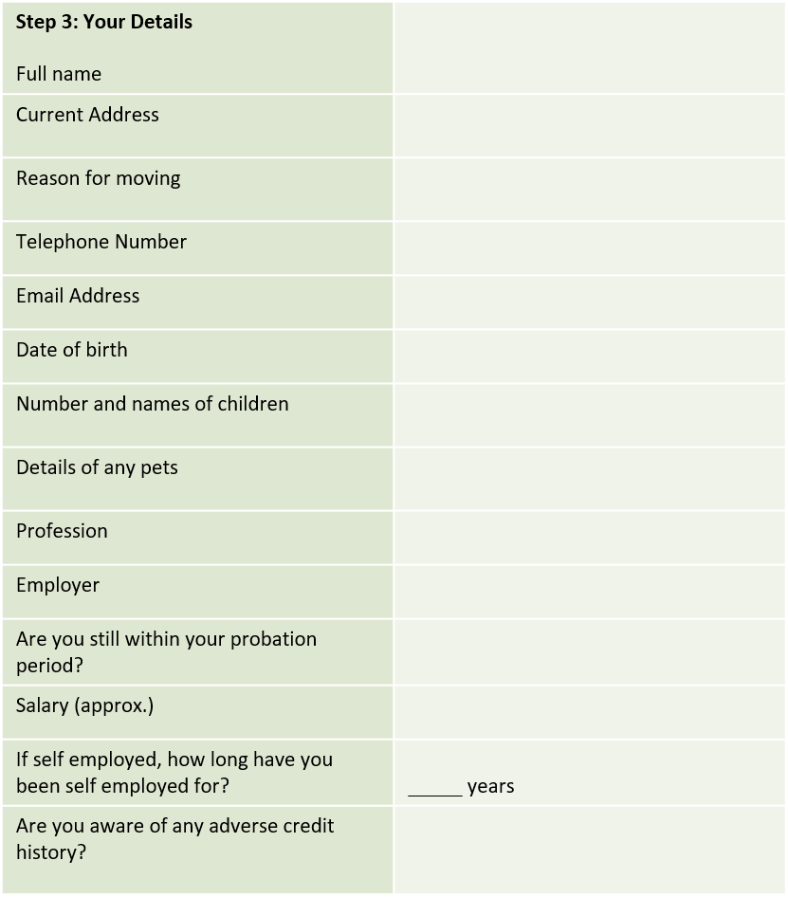

|  |  |
| --- | --- |
| **Step 4: Your Data**  In order to process your application, we use third party companies for reasons detailed below. Please confirm you consent to your data being used in this way. Please contact us if you would like any more information on how, why or with whom your data is shared.  Security is important to us and we have taken provisions to ensure your data is stored in compliance with the most widely accepted security and privacy standards and regulations in the world, such as ISO 27001/2, ISO27018/17 and SOC 2. We will hold your Data for up to 7 years from the date we last processed it during which time you can request your data is deleted from our system. For more information on this process, please request a copy of our Privacy Policy. | |
| **Vorensys Tenant Vetting**  *Vorensys carry out our referencing for us. They will use your data to verify your identity and to contact your referees. They will not use your data for marketing purposes* | Can we pass your information to Vorensys who will need to contact you by telephone and email?  Yes/No (please delete as necessary) |
| **Notify**  *We use Notify to transfer utilities from the existing occupiers name into your name when the tenancy starts and ends.*  *Notify can also compare the market for you and advise you of the best deals for you in relation to utilities, broadband and TV packages. You are under no obligation to follow their advice.*  *We may receive a referral fee from this company* | Can we pass your information to Notify to register you as the new occupier?  Yes/No (please delete as necessary) |
| **The DPS**  *We use the DPS to hold and protect deposits for the duration of the tenancy. Your details will not be used for marketing purposes* | Can we pass your details to the DPS?  Yes/No (please delete as necessary) |

|  |  |
| --- | --- |
| Applicant Name |  |
| Signature |  |
| Date |  |

